Python About:

* Created by Guido Van Rossum
* Released in 1991
* Used for:
  + Server Side Web Development
  + Software Development
  + Mathematics
  + System Scripting
* What can Python Do?
  + Can be used on a server to create web applications
  + Can be used alongside software to create workflows
  + Can connect to database systems
  + Can read and modify files
  + Can be used to handle big data and perform complex mathematics
  + Can be used for rapid prototyping
* Advantages of Python:
  + Works on different platform (Windows, Mac, Linux, Raspberry Pi, etc).
  + Python has a simple syntax similar to the English language.
  + Python has syntax that allows developers to write programs with fewer lines than some other programming languages.
  + Python runs on an interpreter system, meaning that code can be executed as soon as it is written. This means that prototyping can be very quick.
  + Python can be treated in a procedural way, an object-oriented way or a functional way.
* Good to know:
  + The most recent major version of Python is Python 3, which we shall be using in this tutorial. However, Python 2, although not being updated with anything other than security updates, is still quite popular.
  + In this tutorial Python will be written in a text editor. It is possible to write Python in an Integrated Development Environment, such as Thonny, Pycharm, Netbeans or Eclipse which are particularly useful when managing larger collections of Python files.
* Other Information:
  + Python was designed for readability, and has some similarities to the English language with influence from mathematics.
  + Python uses new lines to complete a command, as opposed to other programming languages which often use semicolons or parentheses.
  + Python relies on indentation, using whitespace, to define scope; such as the scope of loops, functions and classes. Other programming languages often use curly-brackets for this purpose.

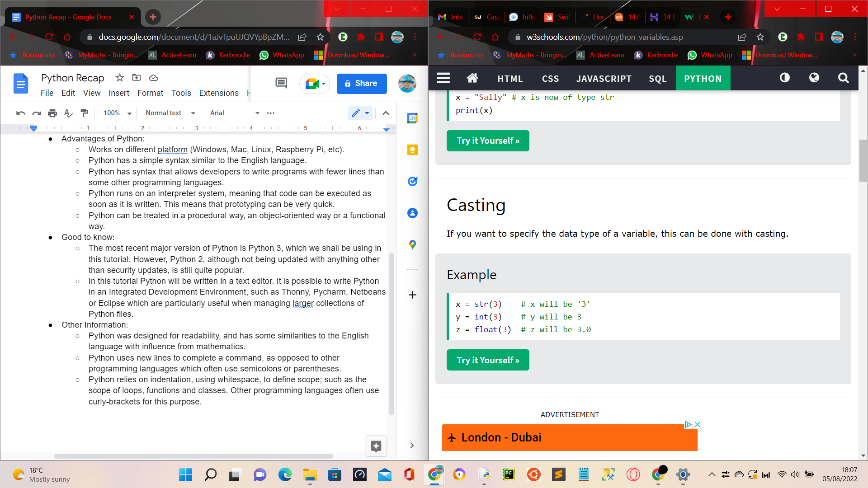

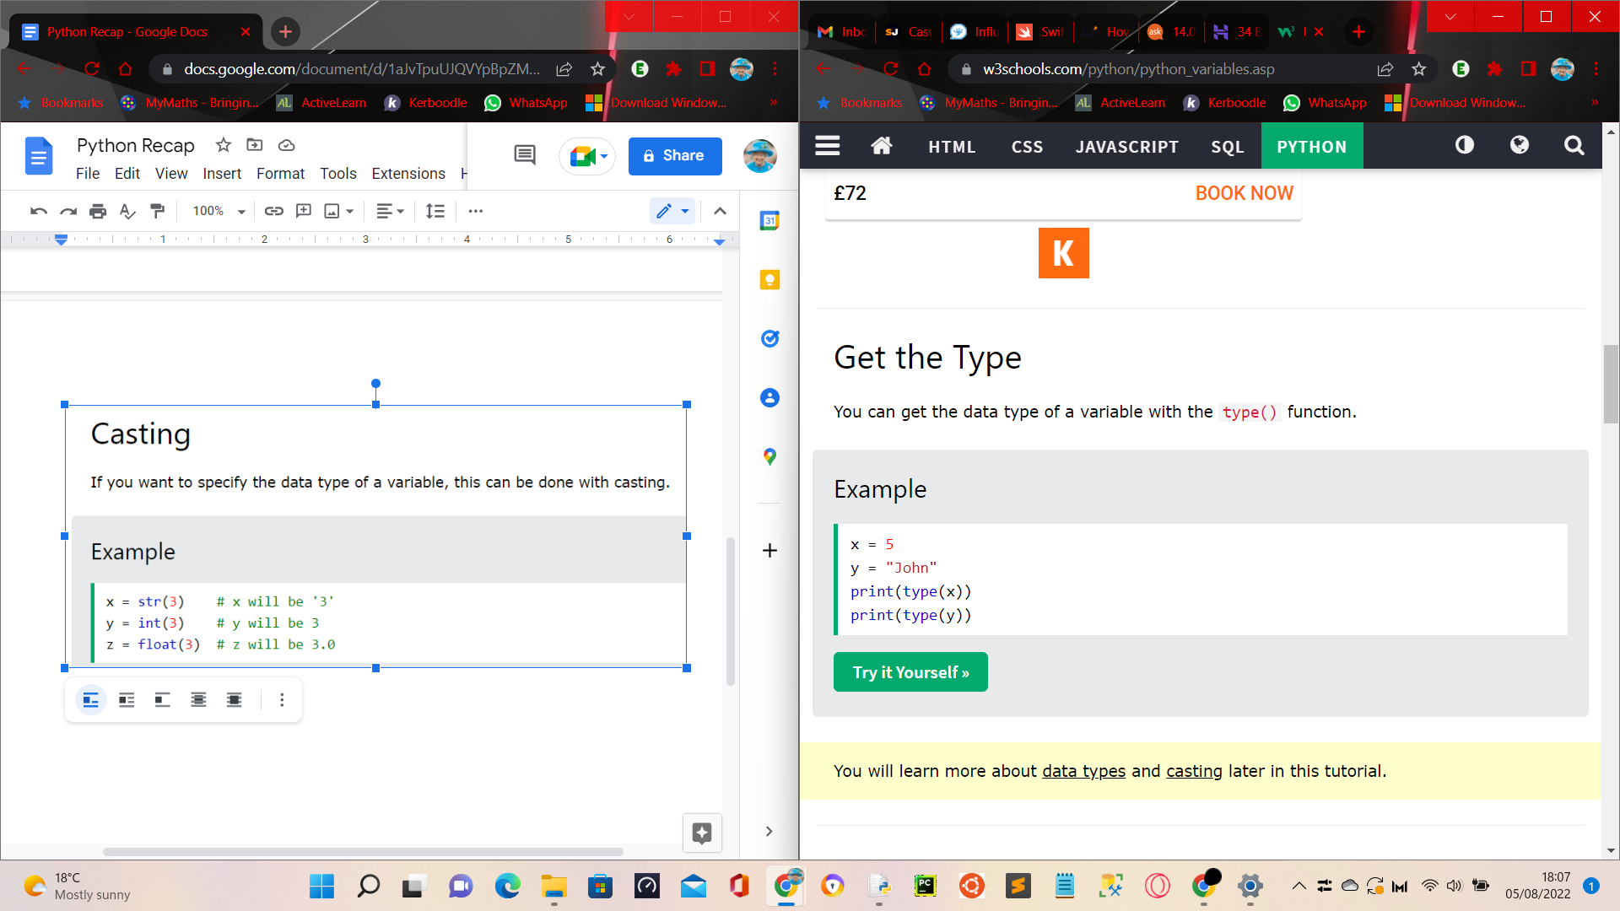

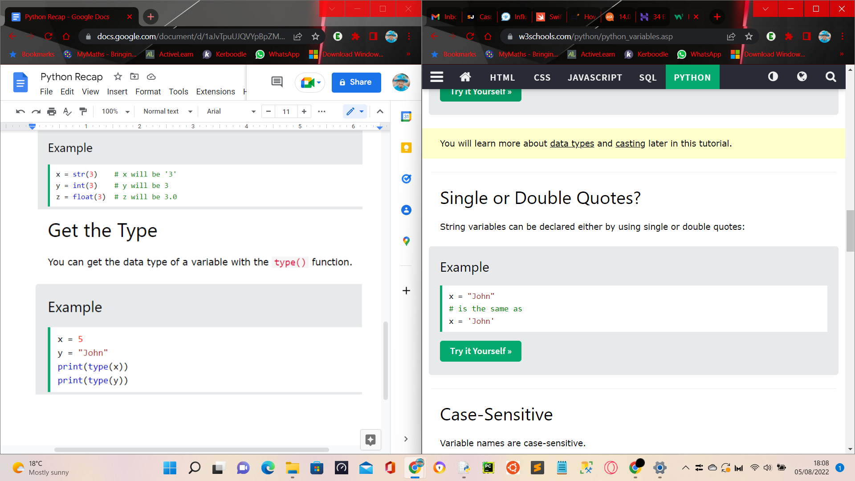

Variable Names:

* A variable can have a short name (like x and y) or a more descriptive name (age, carname, total_volume). Rules for Python variables:
  + A variable name must start with a letter or the underscore character
  + A variable name cannot start with a number
  + A variable name can only contain alpha-numeric characters and underscores (A-z, 0-9, and _ )
  + Variable names are case-sensitive (age, Age and AGE are three different variables)

